INTERDISCIPLINARY PROJECT REPORT
at

Sathyabama Institute of Science and Technology (Deemed to be University)

Submitted in partial fulfillment of the requirements for the award of Bachelor of Engineering Degree in Computer Science and Engineering

By
DODDA SHILPIKA
(Reg.No.40110330)



DEPARTMENT OF COMPUTER SCIENCE AND ENGINEERING SCHOOL OF COMPUTING

SATHYABAMA
INSTITUTE OF SCIENCE AND TECHNOLOGY
(DEEMED TO BE UNIVERSITY)

Accredited with Grade “A” by NAAC | 12 B Status
by UGC | Approved by AICTE

JEPPIAR NAGAR, RAJIV GANDHISALAI, CHENNAI – 600119

APRIL 2023



DEPARTMENT OF COMPUTER SCIENCE AND ENGINEERING

BONAFIDE CERTIFICATE

This is to certify that this Project Report is the bonafide work of DODDA SHILPIKA (Reg.No:40110330) who carried out the project entitled “CREATE YOUR OWN NETWORK IN AWS USING VIRTUAL PRIVATE CLOUD IN AWS” under my
supervision from FEB 2023 to APRIL 2023.

Internal Guide

Dr.M.Selvi.M.Tech., Ph.D.,

Head of the Department

Dr.L.Lakshmanan,M.E., Ph.D.,

Submitted for Viva voce Examination held on

Internal Examiner External Examiner

DECLARATION

I, DODDA SHILPIKA hereby declare that the project report entitled “CREATE YOUR OWN NETWORK IN AWS USING VIRTUAL PRIVATE CLOUD IN AWS” done by me
under the guidance of Dr.M.Selvi.M.Tech., Ph.D., is submitted in partial fulfillment of the requirements for the award of a Bachelor of Engineering Degree in Computer Science and Engineering.

DATE:

PLACE: SIGNATURE OF THE CANDIDATE

ACKNOWLEDGEMENT

I am pleased to acknowledge my sincere thanks to the Board of Management of SATHYABAMA for their kind encouragement in doing this project and for completing it successfully. I am grateful to them.

I convey my thanks to Dr. T. Sasikala M.E., Ph.D., Dean, School of Computing, Dr.L. Lakshmanan M.E., Ph.D., Heads of the Department of Computer Science and Engineering for providing me necessary support and details at the right time during the progressive reviews.

I would like to express my sincere and deep sense of gratitude to my Project Guide Dr.M.Selvi M.Tech., Ph.D., for his valuable guidance, suggestions and constant encouragement paved the way for the successful completion of my project work.

I wish to express my thanks to all Teaching and Non-teaching staff members of the Department of Computer Science and Engineering who were helpful in many ways for the completion of the project

COURSE CERTIFICATE

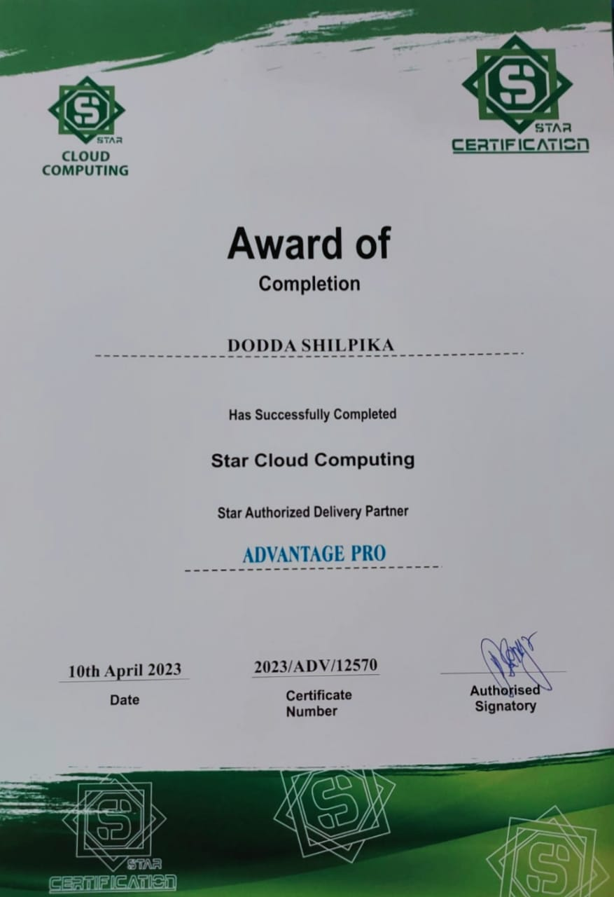

ABSTRACT

Amazon Web Services (AWS) customers often rely on hundreds of accounts and virtual private clouds (VPCs) to segment their workloads and expand their footprint. This level of scale often creates challenges around resource sharing, inter-VPC connectivity, and on-premises facilities to VPC connectivity. This whitepaper describes best practices for creating scalable and secure network architectures in a large network using AWS services such as Amazon Virtual Private Cloud (Amazon VPC), AWS Transit Gateway, AWS Private Link, AWS Direct Connect, Gateway Load Balancer, AWS Network Firewall, and Amazon Route 53. It demonstrates solutions for managing growing infrastructure ensuring scalability, high availability, and security while keeping overhead costs low. In the EC-2 Windows Web Server web Server we need to launch the instance and select the particular servers. After creating key pair, we need to generate the password through the RDP client and decrypt the password. Copy the decrypted password and paste it in the remote desktop connection to create the webserver. A VPC peering connection is a networking connection between two VPCs that enables you to route traffic between them using private IPv4 addresses or IPv6 addresses. Instances in either VPC can communicate with each other as if they are within the same network. Cloud computing is the on-demand delivery of IT resources over the Internet with pay-as-you-go pricing. Instead of buying, owning, and maintaining physical data centers and servers, you can access technology services, such as computing power, storage, and databases, on an as needed basis from a cloud provider like Amazon Web Services (AWS).

i

TABEL OF CONTENTS

CHAPTER No. | TITLE | PAGENo.
 | ABSTRACT | i
 | LIST OF FIGURES  LIST OF ABBREVIATIONS | ii  iv
1 | INTRODUCTION | 1
 | 1.1 INTRODUCTION TO ABOUT VIRTUAL | 1
PRIVATE NETWORK(VPC)

  - What is AWS VPC? 1
  - How does AWS VPC Work? 2
2 AIM AND SCOPE 3
2.1 AIM 3
  - SCOPE 3
  - Best Practices and Use Cases of AWS VPC 3
3 EXPERIMENTAL AND METHOD 4
  - AWS VPC Architecture and Elements 4
  - Create and configure your VPC 4
  - Subnet 5
  - INTERNET GATEWAYS 6
3.5 Route table 8
  - EC2 11
4 SUMMARY AND CONCLUSION 17
  - HARDWARE CONFIGURATION 17
5 REFERENCE 18
5.1 REFERENCE 18
ii

LIST OF FIGURES

FIGURENO. | FIGURENAME | PAGENO.
1.1 | VPC WORK FLOW | 2
2.1 | SOURCE AWS | 3
3.1 | CREATE VPC | 5
3.2 | CREATE SUBNET | 6
3.3 | CREATE INTERNET GATEWAY | 7
3.4 | ATTACH INTERNET GATEWAY | 8
3.5 | CREATE ROUTE TABLE | 9
3.6 | EDIT ROUTES IN ROUTE TABLE | 10
3.7 | EDIT SUBNET ASSOCIATIONS | 10
3.8 | LAUNCH INSTANCES IN EC2 | 11
3.9 | INSTANCE TYPE | 12
3.10 | CONNECT INSTANCE | 13
3.11 | DECRYPT PASSWORD | 14
3.12 | RDP | 14
3.13 | WARNINGS IN RDP | 15
3.14 | AWS WINDOWS | 16
3.15 | NETWORK IS CONNECTED | 17

LIST OF ABBREVIATIONS

ABBREVIATION EXPANSION

AWS
EC2
VPC
CIDR
RDP
AMAZON WEB SERVER
ELASTIC COMPUTE CLOUD
VIRTUAL PRIVATE CLOUD
CLASS INTER-DOMAIN ROUTING REMOTE DESKTOP PROTOCOL

CHAPTER-1

INTRODUCTION

ABOUT VIRTUAL PRIVATE NETWORK(VPC):

There are several reasons organizations should use cloud computing in the modern world. Businesses of all sizes are switching to the cloud to manage risks, improve data security, streamline processes and decrease costs, or other reasons.Many services are available from top cloud service provider Amazon Web Services (AWS) to integrate local resources with the cloud. One such service provided by Amazon is Virtual Private Cloud (VPC). You can use Amazon services in the mentioned virtual network using the Amazon Virtual Private Cloud (Amazon VPC). A virtual private cloud is a network that closely matches the one you would use in your data center (VPC).

Amazon’s Virtual Private Cloud is a core AWS service for both the Compute and Network AWS categories (VPC). Because it is mainly a VPC network is necessary in order to access other AWS services like Elastic Compute Cloud (EC2).

What is AWS VPC?

Using Amazon VPC, you may create a virtual private network between your on - premises resources and the AWS infrastructure. Using this network, you can benefit from AWS’s scalable infrastructure while keeping your environment’s appearance and functionality close to that of a general network you may run in your data center.

Each virtual private cloud (VPC) you create on the AWS cloud is programmable and logically distinct from other virtual networks. You can select the IP address range, set up root tables, create subnets, set up network gateways, and more. Security settings can also be mentioned using security groups and network access control lists. You are in complete control of your virtual networking environment, including the IP address range, route table setup, network gateway setup, and subnet configuration.

The user can regulate security much more in detail VPC by choosing which AWS resources are usable by the public and which are not. It uses the hybrid approach, according to Amazon, but it also wants to meet the rising popularity of private clouds. Your Amazon Web Services includes a default VPC with each Amazon Web Services Region. Your default VPCs are configured to allow you to launch and connect to EC2 instances immediately.

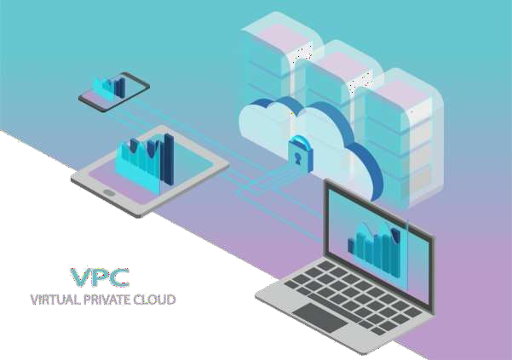
Fig1.1 VPC WORK FLOW

1.3 How does AWS VPC Work?

With Amazon Virtual Private Cloud (Amazon VPC), you have total control over your virtual networking environment, including resource distribution, connectivity, and security. To begin, configure your VPC in the AWS service panel. Then add resources, like Amazon Elastic Compute Cloud instances and Amazon Relational Database Service instances.

Each VPC builds its virtual network for your AWS account in the cloud. To use cloud services, other AWS resources and services are executed inside of VPC networks. Anyone used to managing a physical Data Center will identify AWS VPC (DC). A VPC works similarly to a conventional TCP/IP network that may be grown and expanded. However, a VPC does not explicitly have any DC parts you are accustomed to working with, like routers, switches, VLANS, etc. They were redesigned and abstracted into cloud software. A virtual network that AWS instances will launch can be quickly created using VPC.

Define the communication paths your VPCs will use to interact with one another throughout accounts, Availability Zones, and AWS Regions. The sample below segregates network traffic across two VPCs in each Region.

CHAPTER-2 AIM AND SCOPE
2.1 AIM:

To Create your own network in AWS using VPC in AWS

SCOPE:

A VPC is a logically isolated piece of AWS cloud dedicated to your company. This means, you can run applications on overly provisioned, highly available, and redundant infrastructure setup and it is managed by AWS. All the complexity of setting up a data center with cables, server racks, hardware, power supply, etc. all are managed by AWS. A VPC belongs to a region. A VPC spans all availability zones. You can have multiple VPCs per region. VPC contains one or more subnets. A Subnet is tied to a single availability zone. EC2 instances launch into subnets.

Best Practices and Use Cases of AWS VPC:

A computer with mission-critical workloads needs many security layers to run properly. By using some of these helpful methods, you can secure Amazon Virtual Private Cloud much like your on-site data center.
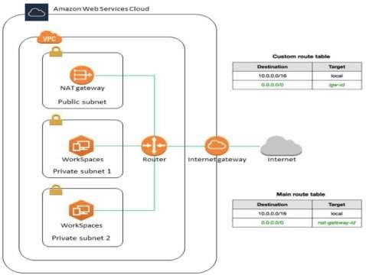

Fig 2.1 Source: AWS

CHAPTER-3

EXPERIMENTAL AND METHODS

AWS VPC Architecture and Elements:

There are many elements involved in creating an AWS VPC. Below are the elements involved in the architecture of AWS VPC:

Create and configure your VPC:

Create a new VPC:

This tutorial uses one of the VPC creation wizards to create the following:
- The VPC
- One of the subnets
- An Internet gateway

To create your VPC using the VPC wizard

1.Open the Amazon VPC console at Console

2.On the VPC Dashboard, choose Launch VPC Wizard.

3.Under Step 1: Select a VPC Configuration, on VPC with a Single Public
Subnet, choose Select.
4.Enter the following information into the wizard and choose Create VPC: IP CIDR block:
10.0.0.0/16

VPC name: SIST VPC

Public subnet:
10.0.0.0/24

5.It takes several minutes for the VPC to be created. After the VPC is created, proceed to the following section to add a second subnet.

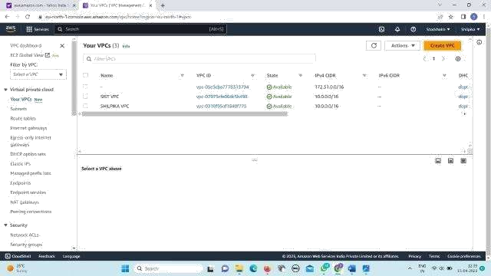
.

Fig 3.1 Create VPC

3.3 Subnet:

AWS Directory Service requires two subnets in your VPC, and each subnet must be in a different Availability Zone. The VPC wizard only creates one subnet, so you must manually create the second subnet, and specify a different Availability Zone than the first subnet. Create the second subnet by performing the following steps

To create a subnet:
1.Open the Amazon VPC console In the navigation pane, select Subnets, select the subnet with the name ADS
2.Subnet 1, and select the Summary tab at the bottom of the page. Make a note of the
availability zone of this subnet.
3.Click Create Subnet and enter the following information in the Create Subnet
dialog box and click Yes, Create. VPC ID:
Select your VPC. This is the VPC with the name SIST VPC Name tag:
SIST Subnet

AVAILABILITY ZONE: No
Preference CIDR Block: 10.0.0.0/24

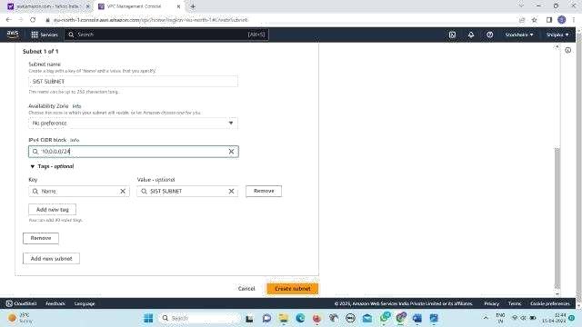

Fig 3.2 create subnet

3.4 INTERNET GATEWAYS:

When more bandwidth, availability, and administrative effort are needed, a network address translation (NAT) gateway is used. An Availability Zone’s public subnet is where the NAT gateway is always located. It makes the necessary changes to the private subnet’s route table to direct traffic to the NAT gateway. When generating, Elastic IP is connected to the NAT gateway. Only the TCP, UDP, and ICMP protocols are supported.

To create an internet gateway and attach it to your VPC:
1.Open the Amazon VPC console at
2.In the navigation pane, choose Internet gateways, and then choose Create internet gateway.
3.Optionally name your internet gateway.
4.Optionally add or remove a tag.
[Add a tag] Choose Add tag and do the following:
- For Key, enter the key name.
- For Value, enter the key value.

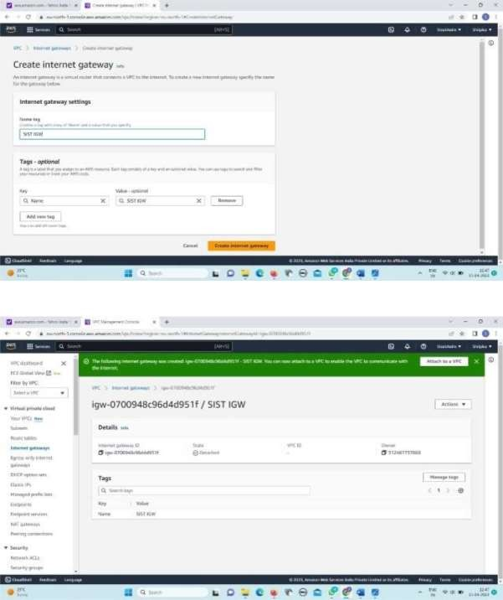

Fig 3.3 Create internet gateway

5.Choose Create internet gateway
6.Select the internet gateway that you just created,and then choose Actions,Attach to VPC.

7.Select your VPC from the list, and then choose Attach internet gateway
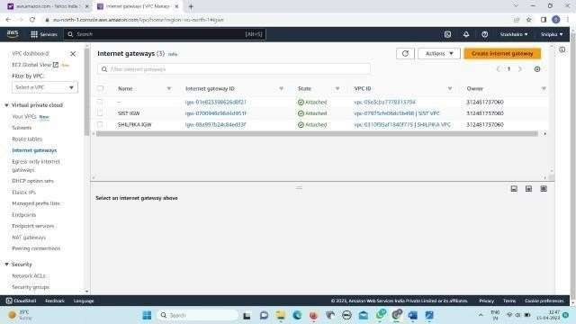

Fig 3.4 Attach internet gateway

Route table:

When you create a subnet, we automatically associate it with the main route table for the VPC. By default, the main route table doesn't contain a route to an internet gateway. The following procedure creates a custom route table with a route that sends traffic destined outside the VPC to the internet gateway, and then associates it with your subnet.

To create a custom route table:
1.Open the Amazon VPC console
2.In the navigation pane, choose Route Tables, and then choose Create route table.

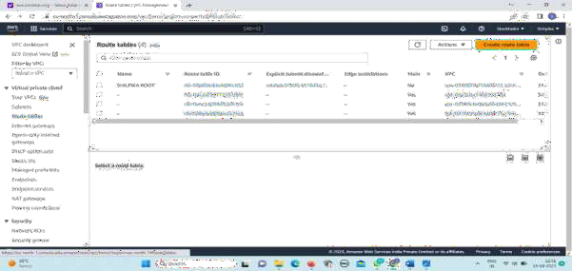

3.In the Create route table dialog box, optionally name your route table, then select your VPC, and then choose Create route table.
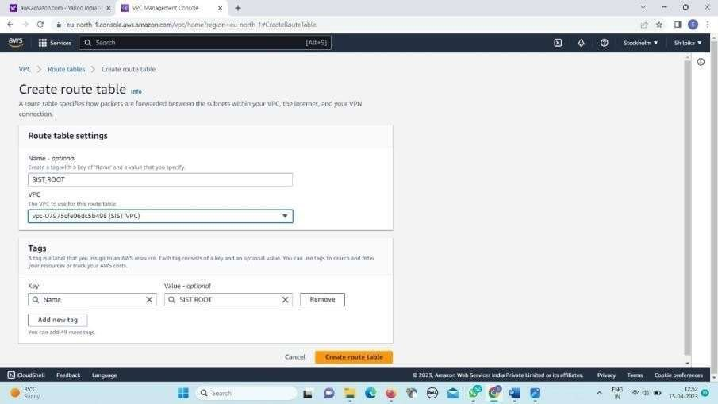
4.Select the custom route table that you just created. The details pane displays tabs for working with its routes, associations, and route propagation.
Fig 3.5 Create route table

5.On the Routes tab, choose Edit routes, Add route, and add the following routes
as necessary. Choose Save changes when you're done.
For IPv4 traffic, specify 0.0.0.0/0 in the Destination box, and select the internet gateway ID in the Target list.

For IPv6 traffic, specify in the Destination box, and select the internet gateway ID in the
Target list
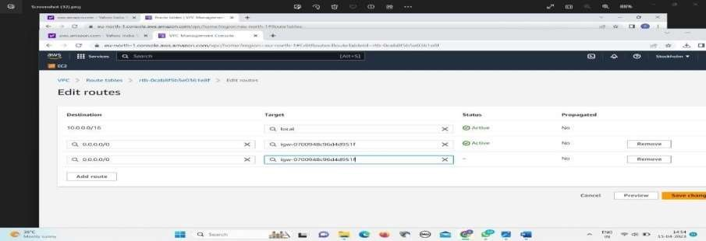
Fig 3.6 Edit routes in route table

6.On the Subnet associations tab, choose Edit subnet associations, select the check
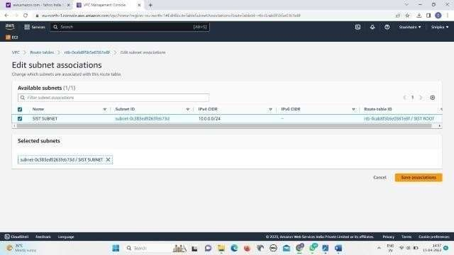
box for the subnet, and then choose Save associations.

Fig 3.7 Edit subnet associations in route table

3.6 EC2:
Launch instance:
1.Open the Amazon EC2 console at
2.From the EC2 console dashboard, in the Launch instance box, choose Launch instance, and then choose Launch instance from the options that appear.
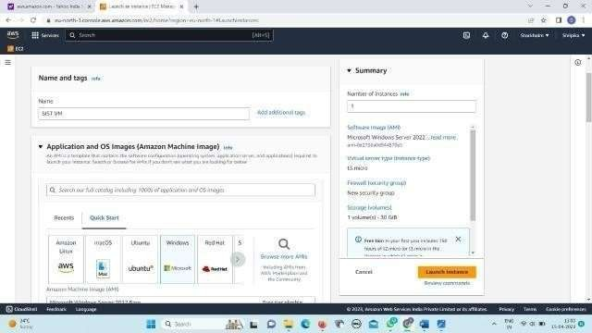
3.Under Name and tags, for Name, enter a descriptive name for your instance.

Fig 3.8 Launch instance in EC2

4.Under Application and OS Images (Amazon Machine Image), do the following: a)Choose Quick Start, and then choose Windows. This is the operating system(OS) for your instance.
b)From Amazon Machine Image (AMI), select the AMI for Windows Server 2016 Base or later.. Notice that these AMIs are marked Free tier eligible. An Amazon Machine Image (AMI) is a basic configuration that serves as a template for your instance.
5.Under Instance type, from the Instance type list, you can select the hardware configuration for your instance. Choose the t2.micro instance type, which is selected by default. The t2.micro instance type is eligible for the free tier. In Regions where t2.micro is unavailable, you can use a t3.microinstance under the free tier. For more information, see AWS Free Tier
6.Under Key pair (login), for Key pair name, choose the key pair that you created when getting set up. Note that you must select an RSA key. ED25519 keys are not supported for Windows instances.

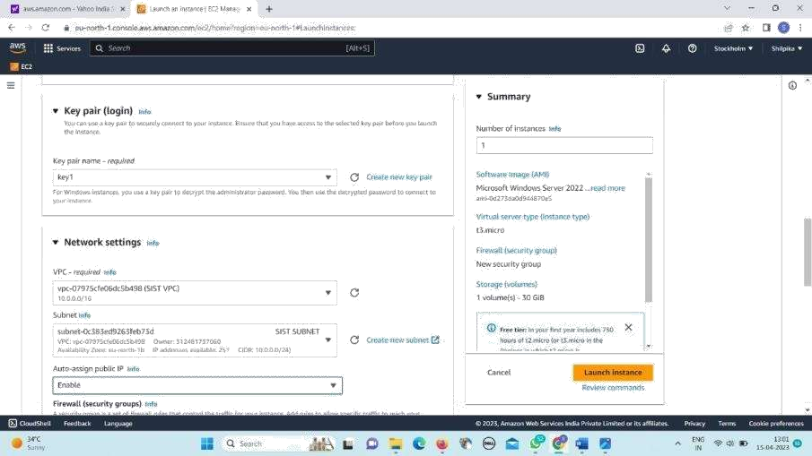

Fig 3.9 Instance type

7.Next to Network settings, choose Edit. For Security group name, you'll see that the wizard created and selected a security group for you. You can use this security group, or alternatively you can select the security group that you created when getting set up using the following steps:
  - Choose Select existing security group.
  - From Common security groups, choose your security group from the list of existing security groups.
8.Keep the default selections for the other configuration settings for your instance.
9.Review a summary of your instance configuration in the Summary panel, and when
you're ready, choose Launch instance
10.A confirmation page lets you know that your instance is launching. Choose View of
all instances to close the confirmation page and return to the console.
11.On the Instances screen, you can view the status of the launch. It takes a short is a
time for an instance to launch. When you launch an instance, its initial state pending
after the instance starts, its state changes to running and it receives a public DNS is
name. If the Public IPv4 DNS column is hidden, choose the settings icon in the top-
right corner, toggle on Public IPv4 DNS, and choose Confirm.

- It can take a few minutes for the instance to be ready for you to connect to it. Check that your instance has passed its status checks; you can view this information in the Status check column.

Connect to your instance:
To connect to a Windows instance, you must retrieve the initial administrator password and then enter this password when you connect to your instance using Remote Desktop. It takes a few minutes after instance launch before this password is available. If you receive an error while attempting to connect to your instance, see Remote Desktop can't connect to the remote computer.

To connect to your Windows instance using an RDP client:
1.Open the Amazon EC2 console at
2.In the navigation pane, select Instances. Select the instance choose Connect. 3.On the Connect to instance page, choose the RDP client tab, choose Get password.
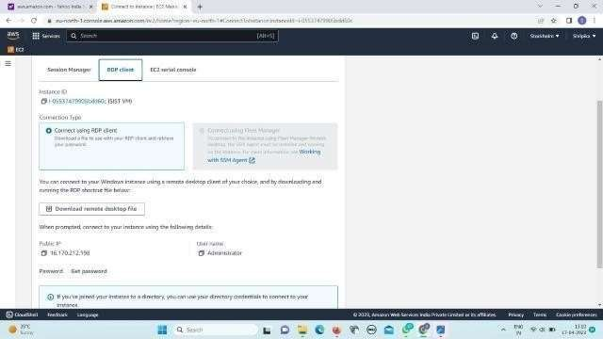

Fig 3.10 Connect to instance

4.Choose Browse and navigate to the private key(.pem) file you created when you
launched the instance. Select the file and choose Open to copy the entire contents
of the file to this window
5.Choose Decrypt Password. The console displays the default administrators the
password for the instance under Password, replacing the Get password link is in a
shown previously. Save the password in a safe place. This password is required to
connect to the instance

13

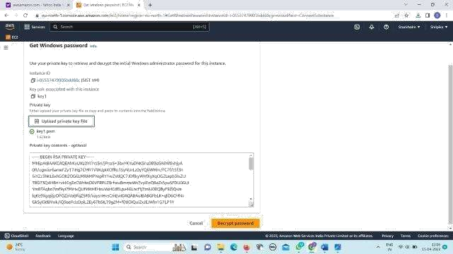
Fig 3.11 Decrypt password

- Choose Download remote desktop file. Your browser prompts you to either open or save the RDP shortcut file. When you have finished downloading the file, choose Cancel to return to the Instances page.
- If you opened the RDP file, you'll see the Remote Desktop Connection dialog box.
- If you saved the RDP file, navigate to your downloads directory, and open the RDP file to display the dialog box.
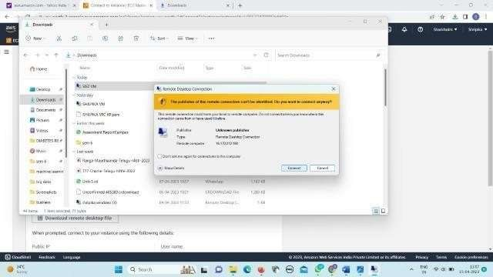
- You may get a warning that the publisher of the remote connection is unknown. Choose Connect to continue to connect to your instance.
Fig 3.12 RDP

6.The administrator account is chosen by default. Copy and paste the password that
you saved previously.
7.Due to the nature of self-signed certificates, you may get a warning that the security
certificate could not be authenticated. Use the following steps to verify the identity of the
remote computer, or simply choose Yes (Windows) or Continue (Mac OS X) if you trust
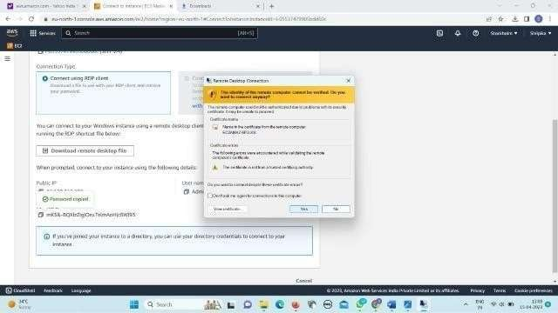
the certificate.

Fig 3.13 warnings in RDP
- If you are using Remote Desktop Connection on a Windows computer, choose View certificate. If you are using Microsoft Remote Desktop on a Mac, choose Show Certificate.
- Choose the Details tab, and scroll down to Thumbprint. This is the unique identifier for the remote computer's security certificate.
- In the Amazon EC2 console, select the instance, choose Actions, Monitor and troubleshoot, Get system log.
- In the system log output, look for RDPCERTIFICATE-THUMB PRINT If this value matches the thumbprint or fingerprint of the certificate, you have verified the identity of the remote computer.
- If you are using Remote Desktop Connection on a Windows computer, return to the Certificate dialog box and choose OK. If you are using Microsoft Remote Desktop on a Mac, return to the Verify Certificate and choose Continue. [Windows] Choose Yes in the Remote Desktop Connection window to connect to your instance.
8. After the above process AWS windows will open
9. Window+R run file will open type CMD command prompt will open

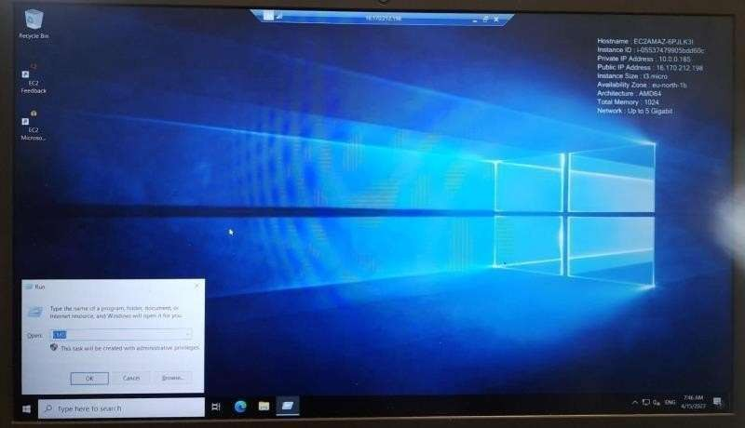
Fig 3.14 AWS windows
10.In command prompt type ping 8.8.8.8 it shows the network is connected or not

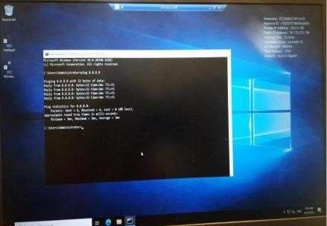

Fig 3.15 network is connected in command prompt

CHAPTER-4 SUMMARY AND CONCLUSION

- CONCLUSION:

So, you may create a virtual network in the AWS cloud using Amazon VPC without hardware, VPNs, or real data centers. You can control how your network and the Amazon EC2 resources it contains are accessible to the Internet, and you can design your own network space.
Some of the key points of VPC are:
  - It helps us in creating a virtual private network on the cloud. You can have your own private network on the cloud rather than on a local network.
  - It has many elements like subnets, NACLs, route tables, etc. These elements
are used to create a VPC and maintain its availability and security.
  - You can also give security settings in your private network using security groups and NACLs options. This helps us secure our cloud network.
  - It is very easy to set up and can be integrated with other AWS services. We can integrate with various AWS services that we are using and make it more of an integrated environment.
When integrating your remote networks with Amazon VPC, AWS offers several effective, secure connectivity solutions to help you make the most of the platform. You can launch AWS resources into a defined virtual network using AWS Virtual Private Cloud. While closely mimicking a traditional network that you would run in your own data center, this virtual network provides the advantages of using the scalable infrastructure of AWS.

CHAPTER-5 REFERENCE

REFERENCE:

[1] CLOUD COMPUTING - Written by: Shailendra Singh
[2] Cloud Computing For Dummies 2nd Edition - Written by: Daniel Kirsch
and JudithHurwitz [198-202].
[3] AWS: The Complete Beginner's Guide - Written by: Stephen Baron.
[4] http://console.aws.amazon.com/ec2/
[5] https://www.analyticsvidhya.com/blog/2022/10/aws-vpc-creating-your-own-virtual-
private-network-on-cloud/
[6] https://youtu.be/NklCW4ngLeI

